Name:___________________________
Text to Self Connection (Title)
Draw or write in the shapes to finish the sentence or idea.
When this happened in the book:
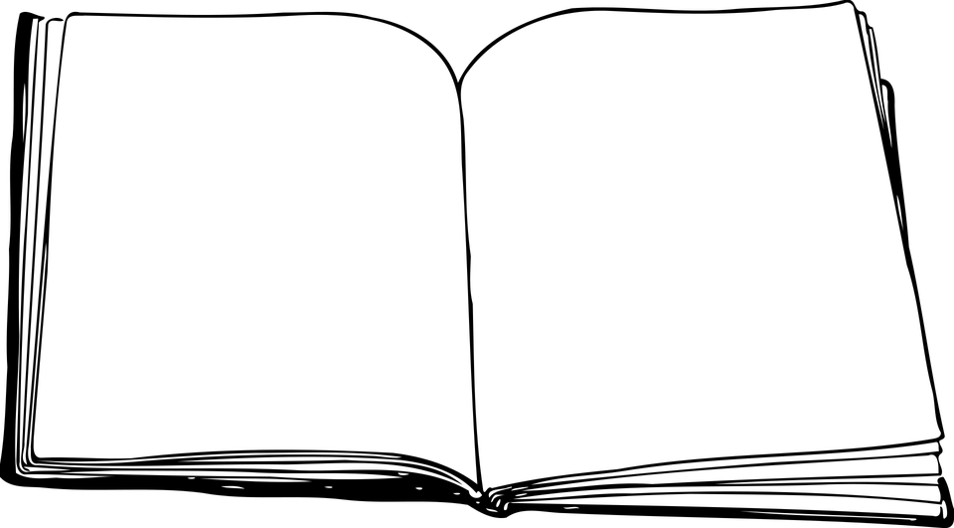

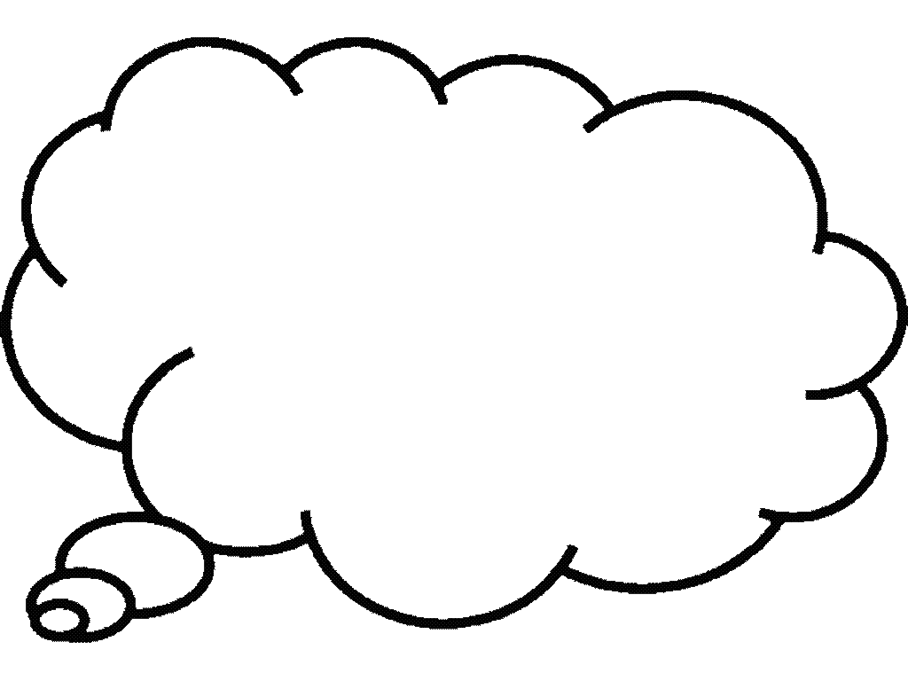
I thought about this in my life:
This Photo by Unknown Author is licensed under CC BY-NC

